Homework Autumn 2nd Half Term
After with previous years we have chosen to keep with the format used for homework and hope that it offers you opportunities to support core academic learning but also to be creative and have fun with learning. The tasks set are optional but it would be good to try at least one PSHE and Topic homework whilst reading remains the single most important thing you can do at home to support your child in school. The school now subscribes to Seesaw and sometimes teachers may suggest that you post your efforts for topic and Personal Moral Spiritual tasks on your journal otherwise bring them into school. The school continues to use the internet based maths resource, Mathletics, and has now also subscribes to Times Table Rockstars. You should have logins for both resources (obtainable from Mrs B or your class teacher). Occasionally teachers may choose to set tasks on Mathletics but if they do not you can practise maths of your choice and Times Table Rockstars is excellent for learning those all important facts. Mathletics certificates and times table bands will be awarded in Friday Celebration assemblies. Teachers will also monitor children’s reading records and two children from each class will be selected at the end of term for a trip to Waterstones in Truro to choose a book that the school will pay for. We hope you have fun supporting learning at home and did I mention that reading is very important.

Reading. Remember reading is probably the most important homework you can do. Try and read every night even if it is just for 10 minutes. Sometimes it is also nice to have stories read to you (these count in your termly total). It is not the number of books you read that matters as some of you will be reading much longer books than others. The important things are that you understand what you are reading and enjoy what you are reading. If this is not the case speak to your teacher because they will do all they can to help you read together at home. You all have a reading record to track your reading so you don’t need to write anything here.
Personal Moral Spiritual  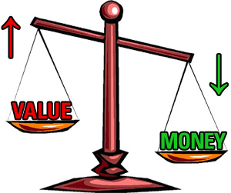  What’s  It Worth? | 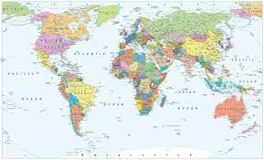  Who am I trading with?  This one is good for understanding how linked we are to other countries via trade and will sharpen your geographical knowledge too! You will need to print off a map of the world and it will help if you have an atlas at home (we have some old ones in school you can have for free if not). Now anything you or your family buy including food but also other things like clothes will usually have a label on saying which country it is from. See how many different countries you have bought things from and maybe put pins on your world map so you learn where they are too. | Worth more than Gold  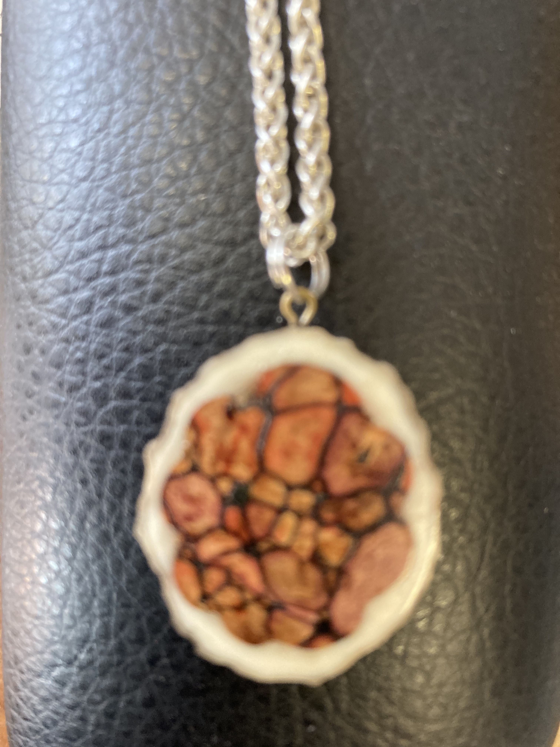  When we do this topic we often discuss what things are worth more than any amount of money. In the book we read in assembly Spinifex the alchemist is obsessed with gold but we know that his apprentice Arthur is right and there are some things that are far more important. Bring a picture or photograph of one such thing to me or Miss Austin in school. We are going to make a display in the hall of what the school believes to be worth more than gold: I’ve started it with a picture of the pressed heather pendant I wear that belonged to my mum. | Giving at Christmas/Solstice  We are coming close to the time of year when gifts are often given with people celebrating Christmas and/or the days beginning to lengthen after the solstice on the 21st. As we all know there are many people who are not as fortunate as us and many charities such as the Salvation Army allow you to make or buy a gift for someone in a difficult situation. Look at some different websites, choose a charity that you want to support and help make someone’s Christmas special. | Creative Enterprise  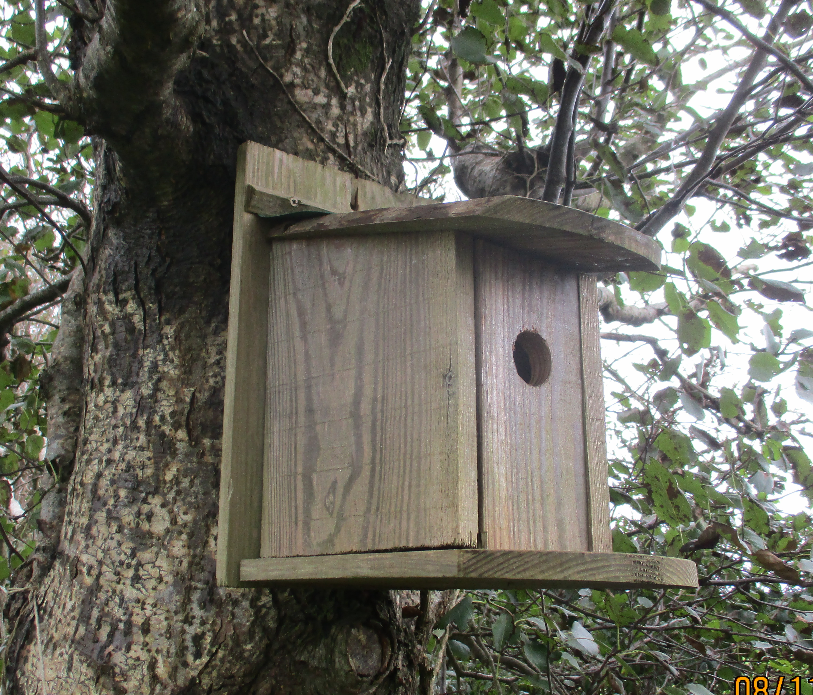  Each of the four classes will be making something to sell at the Christmas Fayre this year and they will get to keep the profits and or donate some to a charity. You are invited to do the same and make something to be sold at the Fayre. If you wish to do this you must let Mr Gardiner know so that he can organise a stall and it is best to get parent help to make sure your products are suitable. We did this through quarantine and several teachers have still got bird boxes that Oska, Anu and family made.
 | Comment | Comment | Comment | Comment
Our Topic | Reading link – Harry Potter  As we continue to read Harry Potter and the philosopher’s stone this half term could you try these activities linked to the text:  - Draw and label a map of Diagon alley.  - Create an invitation letter to Hogwarts including a list of spell books and other items you might need.  - Draw a comic strip of the story so far. | Science link – light and electricity!  Have a go at making your very own light up wizards wand, learning about how circuits work. Here is a simple design for a torch which you could adapt into a light up wizard’s wand.  https://www.science-sparks.com/diy-torch-light-simple-circuit/ | Science link – reversible and irreversible changes.  Irreversible changes can't be undone, however, a reversible change means that the original substance can be retrieved.  Reactions that are reversible include: dissolving, evaporation, melting and freezing.  Can you conduct your own science observation using one of these reactions? You could record how sugar dissolves, chocolate melts or ice freezes. Can you present your results in a chart or graph? | Craft and cooking – create a wizard’s sweet treat!  In the wizarding world of Harry Potter wizards have many different weird and wacky sweet treats – from every flavour beans to chocolate frogs. Can you design and make your own wizard’s sweet treat? You could write the recipe and create an advert for your delicious design.
 | Comment | Comment | Comment | Comment
Mathletics | The school has decided to continue to subscribe to mathletics and we also now have Times Table Rockstars.  Certificates awarded on Mathletics or Rockstars this term and Karate Bands achieved:
 | Comment

