Homework Autumn 2nd Half Term – Godrevy Class
After with previous years we have chosen to keep with the format used for homework and hope that it offers you opportunities to support core academic learning but also to be creative and have fun with learning. The tasks set are optional but it would be good to try at least one PSHE and Topic homework whilst reading remains the single most important thing you can do at home to support your child in school. The school now subscribes to Seesaw and sometimes teachers may suggest that you post your efforts for topic and Personal Moral Spiritual tasks on your journal otherwise bring them into school. The school continues to use the internet based maths resource, Mathletics, and has now also subscribes to Times Table Rockstars. You should have logins for both resources (obtainable from Mrs B or your class teacher). Occasionally teachers may choose to set tasks on Mathletics but if they do not you can practise maths of your choice and Times Table Rockstars is excellent for learning those all-important facts. Mathletics certificates and times table bands will be awarded in Friday Celebration assemblies. Teachers will also monitor children’s reading records and two children from each class will be selected at the end of term for a trip to Waterstones in Truro to choose a book that the school will pay for. We hope you have fun supporting learning at home and did I mention that reading is very important.

Reading. Remember reading is probably the most important homework you can do. Try and read every night even if it is just for 10 minutes. Sometimes it is also nice to have stories read to you. It is not the number of books you read that matters as some of you will be reading much longer books than others. The important things are that you understand what you are reading and enjoy what you are reading. If this is not the case speak to your teacher because they will do all they can to help you read together at home. You all have a reading record to track your reading so you don’t need to write anything here and teachers will now be choosing 2 children from each class every half term for the treat to head to Waterstones in Truro to choose a book the school will pay for.
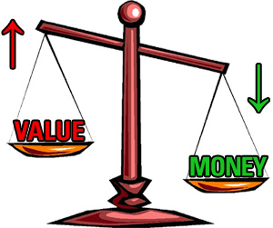  Personal Moral Spiritual  What’s  It Worth? | 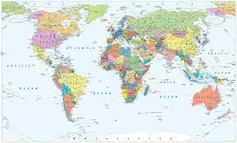  Who am I trading with?  This one is good for understanding how linked we are to other countries via trade and will sharpen your geographical knowledge too! You will need to print off a map of the world and it will help if you have an atlas at home (we have some old ones in school you can have for free if not). Now anything you or your family buy including food but also other things like clothes will usually have a label on saying which country it is from. See how many different countries you have bought things from and maybe put pins on your world map so you learn where they are too. | Worth more than Gold  In the book that we read with this Arthur is sent by his master, Spinifex, to find as much gold as possible. On his travels he finds many things that are not gold but that he thinks are just as valuable – maybe more. In our first assembly several teachers shared an item that is priceless to them. Mrs Eustices scarf – knitted by her sister, my pencil case stitched together by a past pupil, Mrs Gilroy’s box of sand from the beach her husband proposed. Draw a picture or take a photograph of something that is priceless to you but probably not to others and explain why it is so special. | Charity  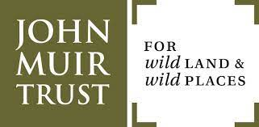  Lots of people like to use some of their money to support a charity and we are coming to a time of year when it is important to think about others and/or trying to help the world. Every month some of my money goes to the John Muir Trust to try and help keep wild spaces in Britain. Who do you think we should give money to? Design a poster to support a charity and show why they are important and in the New Year we will hold a collection for the charity that Student Council believe has the best poster. | Creative Enterprise  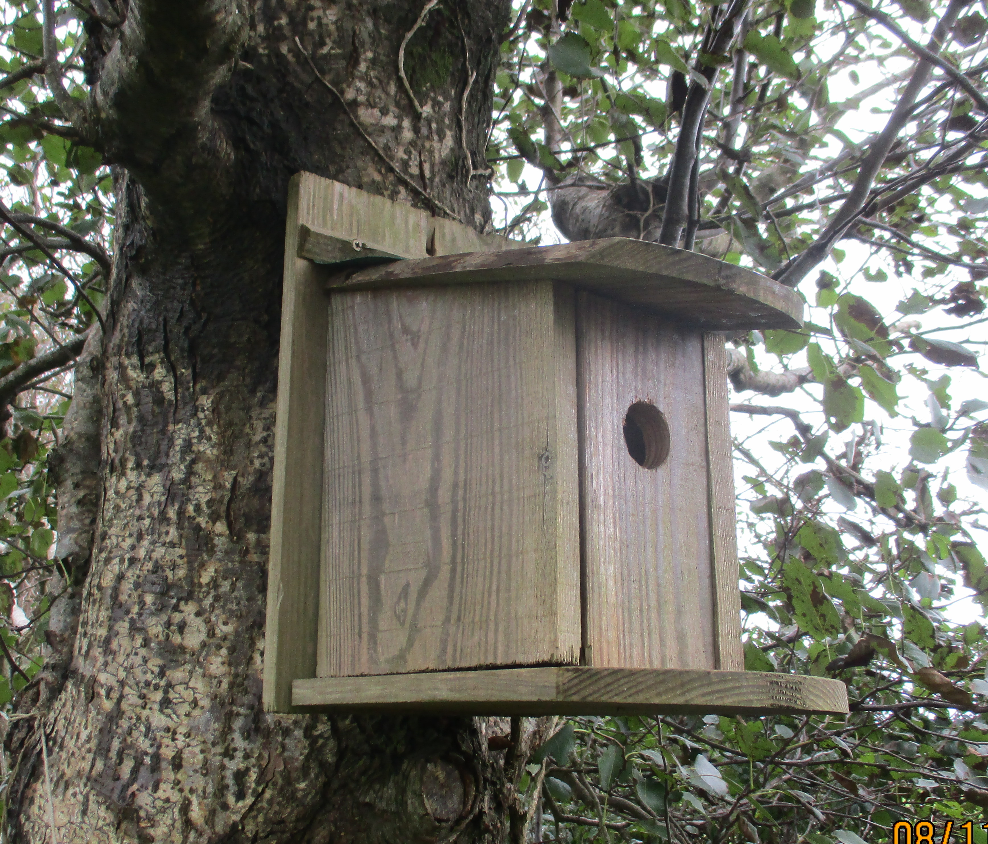  Each of the four classes will be making something to sell at the Christmas Fayre this year and they will get to keep the profits and or donate some to a charity. You are invited to do the same and make something to be sold at the Fayre. If you wish to do this you must let Mr Gardiner know so that he can organise a stall and it is best to get parent help to make sure your products are suitable. We did this through quarantine and several teachers have still got bird boxes that Oska, Anu and family made.
Our Topic  Myths and Magic | 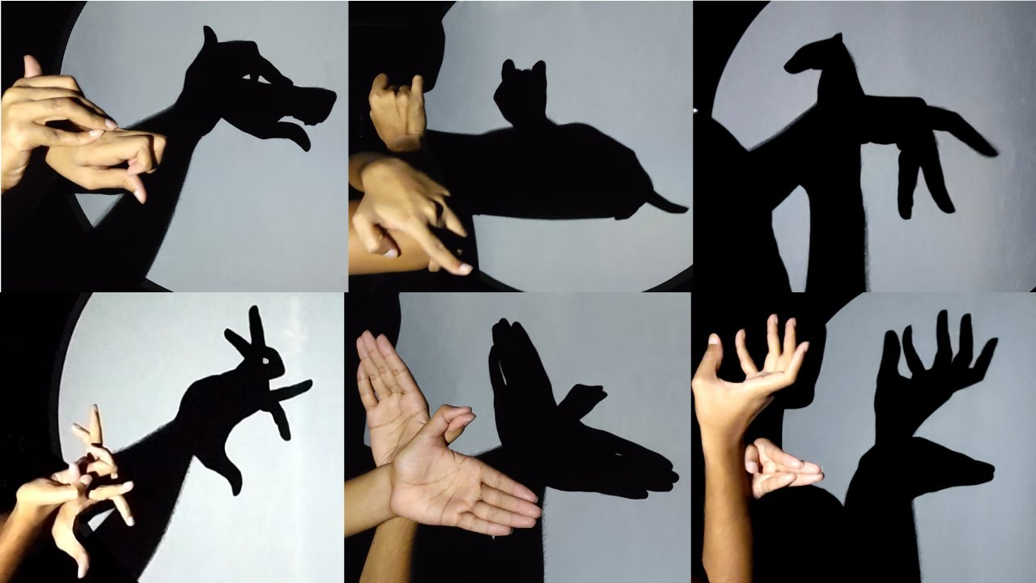  Science - Shadows. In science we are learning about shadows. For this task can you create your own shadow show. You will need a dark room at home and a torch or a lamp. Ask an adult to take photos of your shadow show so you can bring them into class. You could use your hands or even make your own shadow puppets. | 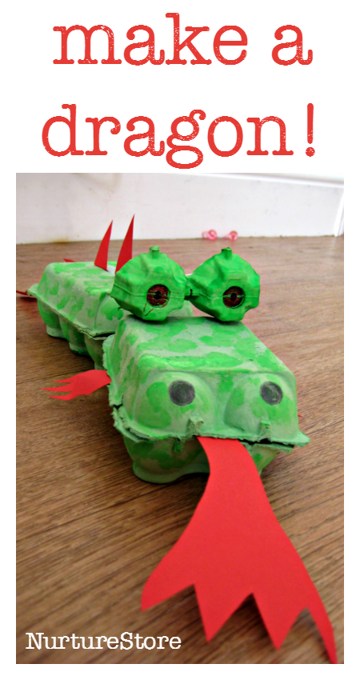  Make a model dragon - We are going to be learning all about dragons and creating our own dragon zoo! Make a model dragon using an egg box like the picture shown. You could choose your own colours and design. | Write a book review - in our class we have a reading scrapbook of all our favourite books. Create a page for it (it needs to be A4 size). You can use pictures and writing.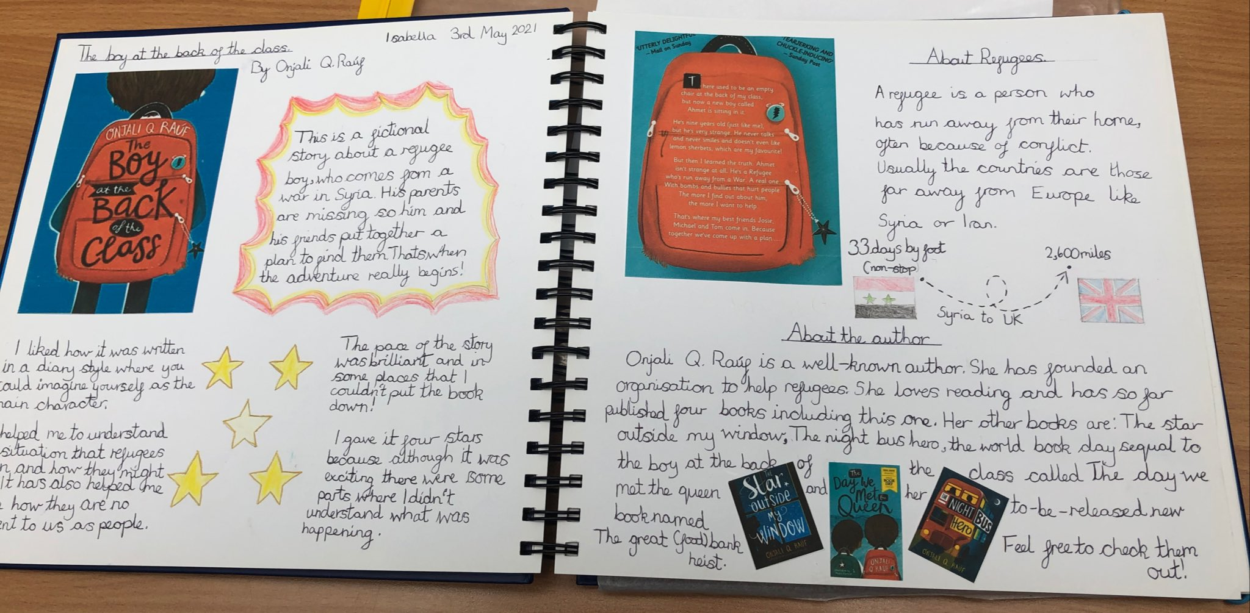 | Writing – Dragon adventure Story  Inspired by the dragons we are learning about in class I would like you to write your own dragon adventure story. Plan it first with characters, build up, problem, resolution and ending. Then write your story either on the computer or with a pencil and paper. Please bring them in for our homework wall.
Mathletics | The school has decided to continue to subscribe to mathletics and we also now have Times Table Rockstars.  Certificates awarded on Mathletics or Rockstars this term and Karate Bands achieved:
 | Comment

